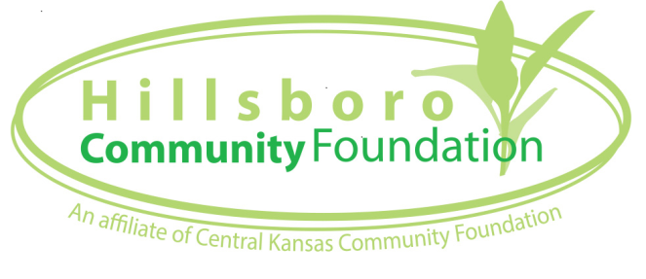
Hillsboro Community Foundation
Grant Application
Applications should be emailed to director@hcfoundationks.org

Organization Name: _________________________________________________________________________
Organization Website: _______________________________________________________________________
Mailing Address: ___________________________________________________________________________
Number/Street
______________________________________ _____________________________ ______________________
City State Zip
Telephone #: (______)_______________ Fax #: (_____)________________
Executive Director/Top Executive: _____________________________________________________________
Title: _____________________________________________________________________________________
Telephone #: (___)______________ Ext: _____ Alternate Telephone #: (____ )____________________
Email Address: _______________________________________________________________________
Project/Program Director (if different than Executive Director/Top Executive): __________________________
Title: _____________________________
Telephone #: (____ ) _____________ Ext: _____ Alternate Telephone #: (____)___________________
Email Address: _______________________________________________________________________
Were you funded in 2015 or 2016 by Hillsboro Community Foundation? □ Yes □ No
If yes, did you submit a follow-up report? □ Yes □ No
If no, you must submit a follow-up report for consideration.
□ Follow-up report is included with this application.

Please provide a brief description of your agency and the population served.

Project/Program Title: ___________________________________________________________________
Type of grant requested.
□ Capacity Building
□ Capital
□ General Operating Support
□ New Project/Program
□ Existing Project/Program
□ Expansion of Existing Project/Program
□ Other _____________________________________________________________________________
Please indicate which categories best reflect the purpose of this request. (You can indicate more than one category if applicable.)
□ Arts & Culture
□ Science & Education
□ Community Preservation & Revitalization
□ Health & Human Services
□ Emergency/Disaster Needs
□ Animal Welfare
□ Other _____________________________________________________________________________
In 100 words or less, please summarize your project/program.

Approximate number of people to be served by this project/program: _________________________________
Date when funds will be needed: ______________________________________________________________
Total project/program cost: $ ____________
Total amount of funding requested (not to exceed $2,500): $ __________
Total grant requests frequently exceed the amount of available funding. Is there a minimum grant amount acceptable for the project/program to proceed? □ Yes □ No
If yes, what is the minimum grant amount acceptable for the project/program to proceed? $ __________
Do you have any pending or committed funding sources for this project/program? □ Yes □ No
If yes, please identify both pending and/or committed source(s) and amount(s).

Is the project/program cost greater than your grant request? □ Yes □ No
If yes, how do you plan to raise the remaining balance?

Is your grant request greater than the cost of your project/program? □ Yes □ No
If additional funding, above the amount of your project/program, was made available to your organization, how would the additional funds strengthen your project/program?

How will this project/program directly impact the community of Hillsboro?

How does this request embody one or more of the following:

Urgency or immediacy to address a critical need;

Excitement because it’s a bold new venture;

Creativity in providing new solutions to age old problems.

How did you determine the need for this project/program?

How will you evaluate the success of your project/program?

□ Organization is a 501(c)(3).
□ Proof of 501(c)(3) status is included with this application.
□ Organization is not a 501(c)(3).
Is your organization a public agency/unit of government?
(i.e., educational institution, church, a city, or county) □ Yes □ No
If no, please identify the qualified organization that will serve as the project/programs fiscal sponsor.
Name of Organization: ___________________________________________________________
Contact Person: ________________________________________________________________
Mailing Address: _____________________________________________________________________
Number/Street
___________________________________ ____________________________ ____________________
City State Zip

Telephone #: (_____)__________ Ext: _____
Email: ________________________________________________________________________

□ Proof of project/programs fiscal sponsor’s 501(c)(3) status is included with this application.
Employer Identification Number (EIN): ___________________________________________________

We give permission to use our group’s name and project/program in publicity. □ Yes □ No

***********************************
I certify, to the best of my knowledge, that all information included in this application is correct. The tax exempt status of this organization is current. If grant is received through the Hillsboro Community Foundation, an affiliate of Central Kansas Community Foundation, for the purposes described herein shall be restricted as stated herein.
________________________________ ________________________
Signature of Representative Requesting Grant Date

Hillsboro Community Foundation, an affiliate of Central Kansas Community Foundation, manages the Hillsboro Area Impact Fund. If you have questions or need further information, please contact Cynthia Fleming director@hcfoundationks.org or 620-947-0170.

